Database Systems Lab # 11
By:
Abubakar Shahid
21L-5845
BSE-4B2

SS with message as output:-

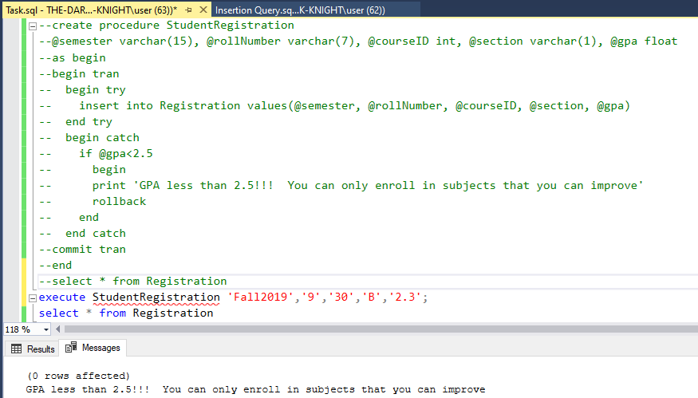

SS with table as evidence:-

